ATTACHEMENT xx Chard and District Museum
Annual General Meeting 03-07-24
UPDATE Margaret Bondfield Steering Group

Collections and Visitor Experience Group

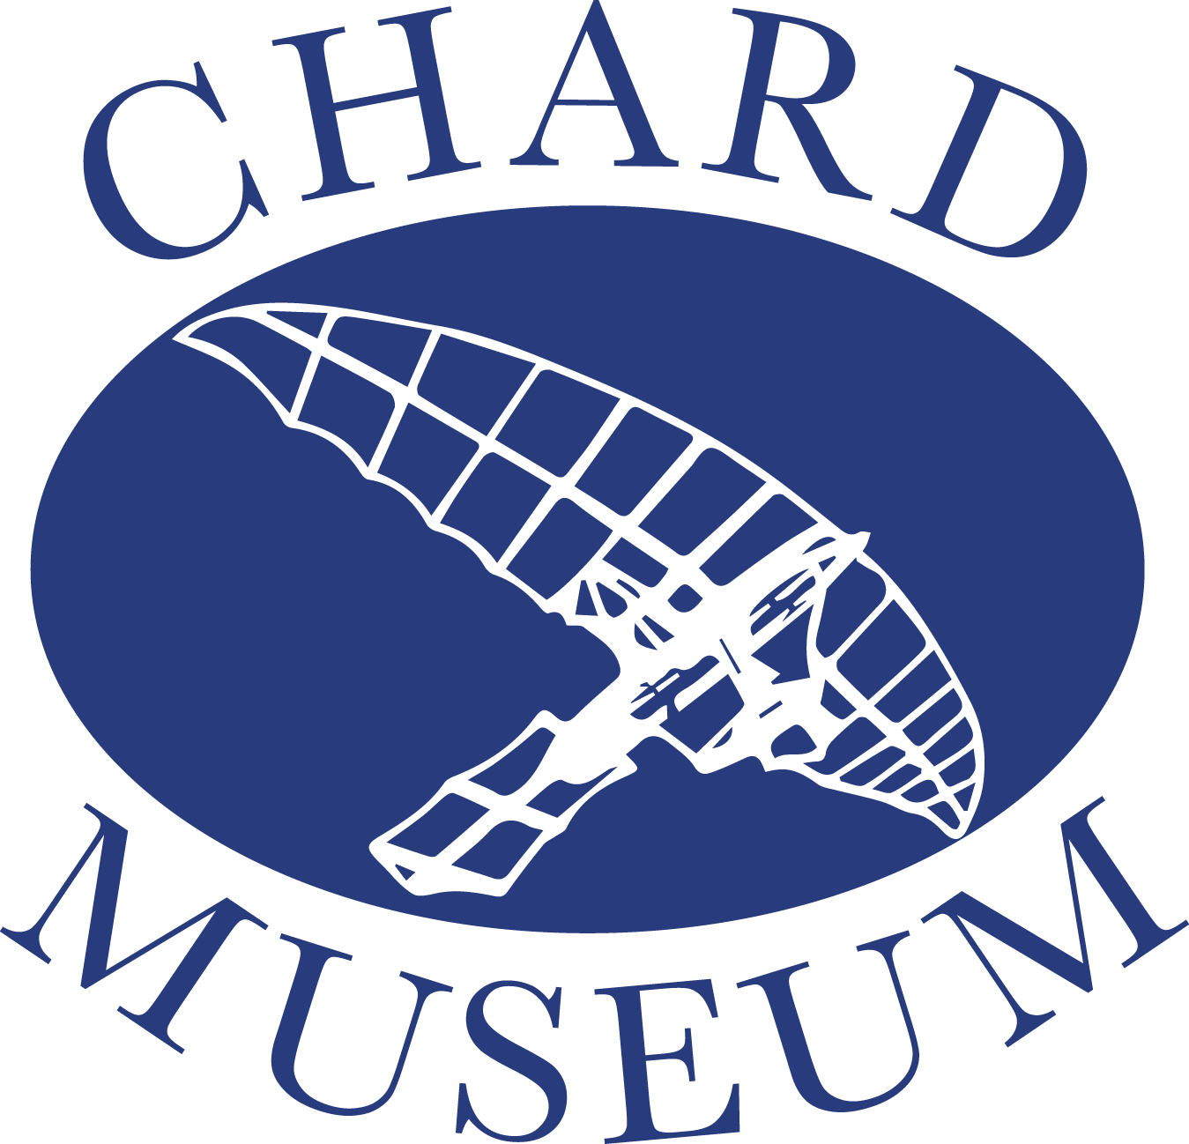

Margaret Bondfield is one of the Museum’s ‘Chard Five’. The Margaret Bondfield Steering Group was formed at the end of 2023 with the aim of supporting the celebration of Margaret Bondfield’s life and work, during the centenary of her becoming a Government minister and her appointment as the first female Cabinet Minister in 2029.

The first event was a lecture given at the end of 2023 by the trade unionist, John Gray, which was followed by a week-long visit at the beginning of 2024 from Sue Dockett. Sue wrote the booklet ‘Out of the Wilderness’ on sale in the museum which has proved the inspiration for many members of the Steering Group. During a full week, Sue visited several local schools and gave a talk at the Guildhall as well as an interview to BBC Somerset, among other activities.

Following the success of the celebration marking Margaret Bondfield’s birthday in March this year, it is hoped to make this an annual event to coincide with the opening of the museum.

An exhibition of the photographs used for the birthday celebration was mounted on the long display board in Chard library between 16th April and 31st May. A timeline was attached across the bottom of the board with photographs and captions to illustrate the major events of MB’s life.

Richard Tomlinson produced an impressive lenticular artwork of Margaret Bondfield and the A1 version now hangs in the foyer of the Guildhall. It is intended to offer the remaining A4 versions to the schools in Chard with steering group members giving a short school assembly to explain the importance of Margaret Bondfield’s achievements.

Year 12 Performing Arts students from Holyrood School visited the museum to research Margaret Bondfield and have since produced a short piece of drama in education for Year 3 students (7-8 year olds). This is based around equality and speaking up for others. School visits have been planned for Neroche, Avishayes and Redstart in July.

Plans have been discussed for the following regular activities over this 5-year project:
- Walking Carnival as an annual entry commencing in 2024.
- Community Play for 2025 and 2027
- Music Festival 2026 and 2028 as part of the museum’s Heritage and Arts Week
- Mural. The subject and location are under discussion.
Funding would be sort from an initial bid to the Arts Council Grant to support these projects.

- The idea of a literary festival and a debating competition is also being considered. It is hoped during the five-year period to invite Nan Sloane, the Labour historian to visit Chard. Nan is currently writing a biography of MB and has a wide knowledge concerning the formation of the Labour party. Funding for a possible visit and debate could come from a further Arts Council Bid.

- Somerset Museum would be approached to consider hosting a Margaret Bondfield exhibition during the lifetime of the project.

STATUE: This was discussed at the last Steering Group meeting and members were keen that this idea should be taken forward. However, it was agreed that in light of the museum’s commitments, a separate group would be formed. This has since met and is exploring possible sites and planning permission before proceeding with fund-raising.

VASSAR COLLEGE: The college had been contacted to see if access could be granted to view the papers held in the Margaret Bondfield special collection. However, these are not available on line so an offer was made by the museum to help fund scanning the papers with possible help from Bristol University. This offer was turned down by the college due to Vassar staff time and expense but an offer was given to provide some material to add to the museum’s website. Further discussions are planned to gain access to the archive.

TOLPUDDLE FESTIVAL: Sue Dockett had suggested that the annual Tolpuddle Festival would be a good event at which to promote MB. Festival to be visited this year to explore this idea. If it is felt this is a suitable event then funding would be required for entry and possible accommodation for volunteers together with possible flyer to hand out to interested festival visitors.

CHILDREN’S BOOK: There are several illustrated children’s books featuring Mary Anning and it is hoped to explore the idea of working with local children to develop a publication for Margaret Bondfield along with an activity pack.

ARTS COUNCIL BID
An initial bid should be ready for submission in August 2024.

